Wesley Gore

jwesgore@gmail.com

Abstract

Hurricanes are becoming worse with time as mankind continues to pollute the air with carbon, methane, and other greenhouse gasses. The damages caused by hurricanes is already substantially worse than before and will continue to worsen unless we can shift as a society to reusable alternatives over single use items and nonrenewable fuel sources. I observe the possible effects of worsening hurricanes as well as a solution to reeducating the public to help slow and one day halt the warming of our atmosphere.

Slowing the Storm

Climate change and its impact on future hurricanes

# Table of Contents

Table of Contents 1

1 Hurricanes are really not good 2

1.1 Hurricanes 2

1.2 Climate Change 2

2 Stop filling the atmosphere with poison 3

2.1 First Steps 3

2.2 Future Action 3

3 How to fix the world 3

3.1 Effective Education 3

3.2 Technology 4

3.3 Incentives 4

4 Conclusion 4

5 Bibliography 5

5.1 References 5

5.2 Photos 5

Error! Hyperlink reference not valid.Error! Hyperlink reference not valid.Error! Hyperlink reference not valid.Error! Hyperlink reference not valid.Error! Hyperlink reference not valid.Error! Hyperlink reference not valid.Error! Hyperlink reference not valid.Error! Hyperlink reference not valid.Error! Hyperlink reference not valid.Error! Hyperlink reference not valid.Error! Hyperlink reference not valid.Error! Hyperlink reference not valid.Error! Hyperlink reference not valid.Error! Hyperlink reference not valid.Error! Hyperlink reference not valid.Error! Hyperlink reference not valid.Error! Hyperlink reference not valid.Error! Hyperlink reference not valid.Error! Hyperlink reference not valid.Error! Hyperlink reference not valid.Error! Hyperlink reference not valid.Error! Hyperlink reference not valid.Error! Hyperlink reference not valid.Error! Hyperlink reference not valid.Error! Hyperlink reference not valid.Error! Hyperlink reference not valid.Error! Hyperlink reference not valid.Error! Hyperlink reference not valid.Error! Hyperlink reference not valid.Error! Hyperlink reference not valid.

Table of Figures

Figure 12

Figure 23

Figure 34

# Hurricanes are really not good

## Hurricanes

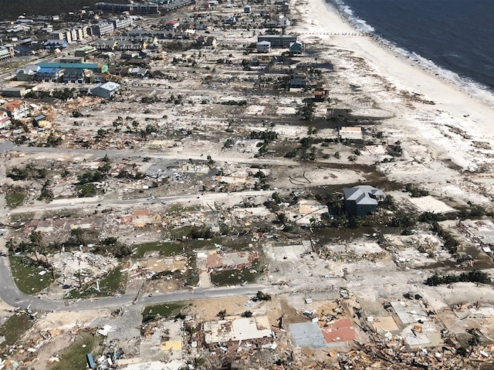Hurricanes can cripple and destroy a community’s property, economics, and lives. One example reported by CNN of how “The town of Mexico Beach was devastated by [hurricane Michael]. Out of 1,692 buildings in town, 1,584 buildings were reported damaged, with 809 of those reported destroyed.” (Hurricane Stat.). The blow to Mexico Beach is unfortunately not a unique situation with the congressional budget office also reporting “Expected annual economic losses from most types of damage caused by hurricane winds and storm-related flooding total $54 billion—$34 billion in losses to households, $9 billion to commercial businesses, and $12 billion to the public sector.” (Expected Costs). Despite warning and reports of how deadly Hurricane Michael would be:

*“320,000 people did not evacuate the path of Hurricane Michael as it approached the Florida coast, where it went on to devastate the coast and kill at least two people and leave 280 missing. More than 500,000 people were under mandatory evacuation notices or urged to find higher ground before the hurricane, the strongest ever recorded in the region, hit.” (Business Insider).*

Figure 1: Mexico Beach, FL after Hurricane Michael

At first glance this may seem to have simply been out of stubbornness, however Business Insider clarifies later in the article, “… many people were not able to leave, for financial reasons or due to disability or illness” (Business Insider). Evacuation needs to be available for all citizens despite their condition.

## Climate Change

There is a growing, and ever present, problem the world is facing and that is the effects of climate change. The scientific community has long backed the existence of anthropogenic global warming (AGP). In a research letter posted to IOP Science about whether there was in fact a consensus on the issue of climate change, they claimed “We have shown that the scientific consensus on AGP is robust, with a range of 90%–100% depending on the exact question, timing and sampling methodology” (Consensus on consensus). The effects of climate change are wide ranging with NASA on their website listing a few as increased temperatures, frost-free seasons, changes in precipitation patterns, increased heat waves, increased sea level, and more intense hurricanes (The Effects). This last inclusion is quite troubling given the already intense nature of the damages caused by hurricanes. From this we can see how climate change has the potential to intensely worsen an already difficult and damaging issue. In a report by The Guardian, they talk about this relationship between climate change and hurricanes saying:

*“While the overall number of hurricanes has remained roughly the same in recent decades, there is evidence they are intensifying more quickly, resulting in a greater number of the most severe category four and five storms. The proportion of tropical storms that rapidly strengthen into powerful hurricanes has tripled over the past 30 years…”(The Guardian).’*

We must take action against climate change to stop the intensifying hurricane issue.

# Stop filling the atmosphere with poison

## First Steps

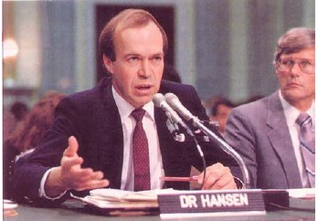To address this issue of climate change we must

* Educate the public in the reality and effects of climate change, especially in regard to intensifying storms,
* Develop economic projections to accurately model an ROI return timetable of investing into green technology development in oceanside cities,
* Create, or increase, budgeting towards green technology development education at the high school level which encourage teens to put their minds towards thinking of green alternatives to current technologies which exist,

Figure : James E. Hansen, former Director of the NASA Goddard Institute for Space Studies, testifying before congress on the importance of addressing climate change 1988

* Invest into technologies that will cool sea and ocean water temperatures.

## Future Action

Solving this is a long-term commitment and thus initial action will not be enough. We must also

* Invest into renovating existing infrastructure to be more eco-friendly,
* Implementing technologies developed during the starting phase,
* Use the destruction of future hurricanes to rebuild in a way which will further hurricane proof the area as well as utilizing existing green technologies to more easily shift towns into new eco-friendly systems and infrastructure.

# How to fix the world

## Effective Education

Solving such a ginormous task seems like an impossible undertaking, but the solution to any problem starts with the first step of understanding the issue. In an article by Climate Reality Project, they tell of a teacher which had to actively work against the teachings of one of her colleagues for promoting anti-climate change narratives (Project). This shows a fundamental flaw in our system that shows that at the base level of learning there is an attack on climate science. This is often cited as “teaching both sides”, however as we have seen, experts are overwhelmingly in agreement that anthropomorphic global warming is happening. With this position of “teaching both sides”, it casts climate denial as equal to the reality of AGP when it is not in the eyes of most experts. Only by teaching the truth can we grow in our understanding of issue so that we may effectively combat it. To combat this, we should require climate science to be a requirement in high school taught by properly vetted teachers that will teach fact and not politics.

## Japan's next generation of renewable energyTechnology

There are several speculative technologies which could be promising to invest into to cool sea water temperatures. This is a necessary step as increasing temperatures is what leads to more easily developing and more intense hurricanes. There are several ideas being entertained with one being reflective chemical agents which could reflect sunlight thus cooling ocean temperatures. This idea is useful as dark ocean water reflects only 6% of the sunlight that reaches it, absorbing the other 94% as heat create water vapor, a greenhouse gas (BBC).

Figure 3: Artistic rendering of experimental "wind lenses" being showcased at the Japanese Yokohama Renewable Energy Exhibition

## Incentives

One of the hardest parts of developing and implementing eco-friendly technologies is the general large up-front costs associated with it. Although these costs are large in the short term, most eco-friendly alternatives have strong ROI in the long term. This is not always enough to sway people into switching however, so, providing economic incentives could help pad out the initial economic stain. The by the state government providing incentives towards houses installing solar panels and other green technology, this could help encourage citizen to take the leap into investing. These incentives would not be totally lost revenue by the state as citizens utilizing these technologies will remove stain from the electrical grid and, in some instance, the houses will be able to generate electricity for the state to use.

# Conclusion

Developing technologies for fighting against climate change is a necessary action we must be pursuing with full intensity. Warming ocean and seawater temperatures are creating a breeding ground for more and more intense climate activity. After the devastation of storms such as Hurricane Michael we can see how our actions are having a direct impact on the intensity of hurricane development and the destruction that comes it. We are not gods, but these storms are also not direct acts of providence. These storms are scientific occurrences which have known variables which lead to their formation. We may not be gods, but we have the tools, the brainpower, and the necessity to do what is needed to slow the storm.

# Bibliography

## References

“Hurricane Statistics Fast Facts.” *CNN*, Cable News Network, 2 June 2020, www.cnn.com/2013/05/31/world/americas/hurricane-statistics-fast-facts/index.html.

“Expected Costs of Damage From Hurricane Winds and Storm-Related Flooding.” *Congressional Budget Office*, 10 Apr. 2019, www.cbo.gov/publication/55019#:~:text=Expected%20annual%20economic%20losses%20from,billion%20to%20the%20public%20sector.

Baker, Sinéad. “280 Unaccounted for in Hurricane Michael as FEMA Warns 'People Do Not Live to Tell the Tale' of Storm Surges.” *Business Insider*, Business Insider, 11 Oct. 2018, www.businessinsider.com/hurricane-michael-ignored-evacuation-florida-2018-10.

Milman, Oliver. “Are Hurricanes Getting Stronger – and Is Climate Breakdown to Blame?” *The Guardian*, Guardian News and Media, 20 May 2019, www.theguardian.com/world/2019/may/20/are-hurricanes-getting-stronger-and-is-the-climate-crisis-to-blame.

Project, The Climate Reality. “Back to School: We Can't Let Deniers Scrap Climate Science Education.” *Climate Reality*, 6 Nov. 2019, www.climaterealityproject.org/blog/back-school-we-cant-let-deniers-scrap-climate-science-education.

“How Artificially Brightened Clouds Could Stop Climate Change.” *BBC Future*, BBC, www.bbc.com/future/article/20190220-how-artificially-brightened-clouds-could-stop-climate-change.

Consensus on consensus: a synthesis of consensus estimates on human-caused global warming. John Cook et al 2016 Environ. Res. Lett. 11 048002. Retrieved July 17, 2020, https://iopscience.iop.org/article/10.1088/1748-9326/11/4/048002

The Effects of Climate Change. (2020, June 09). Retrieved July 17, 2020, from https://climate.nasa.gov/effects/

## Photos

S. (2015, September 8). *Hurricane Catrina*. Retrieved July 17, 2020, from https://pixabay.com/photos/hurricane-catrina-923808/

Coast Guard News. *Hurricane Michael Overflight of Mexico Beach, Fl*, Flickr, Mexico Beach, FL, 11 Oct. 2018, www.flickr.com/photos/coastguardnews/45206940182.

Ocko, Ilissa. “Hansen Was Right: Marking an Anniversary by Misleading the Public.” *Climate 411*, 31 July 2018, blogs.edf.org/climate411/2018/07/18/hansen-was-right-marking-an-anniversary-by-misleading-the-public/.

UNUniversity. “Japan's Next Generation of Renewable Energy.” *Our World*, ourworld.unu.edu/en/japans-next-generation-of-renewable-energy.